Facilities Management
Environmental Health and Safety

J. Daniel Core
1200 Murchison Road
Fayetteville, NC 28301

910-672-1111 Phone
910-672-1443 Phone
Safety@uncfsu.edu

Asbestos Safety Program

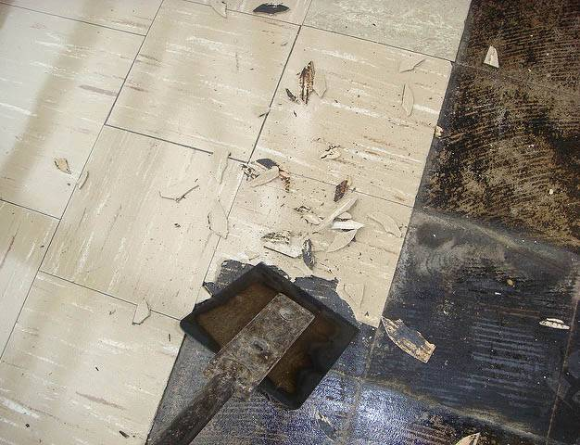
Prepared by:
Facilities Management

J. Daniel Core
1200 Murchison Road
Fayetteville, NC 28301

910-672-1111 Phone
910-672-1443 Phone
Safety@uncfsu.edu
EHS Officer: jcore2@uncfsu.edu

Contents
Scope 3
Responsibilities 3
Definitions 4
General Information 5
Abatement Projects 6
References 7

﻿Introduction
Fayetteville State University’s Environmental Health and Safety Office (EHS) has developed this Program to identify practices and procedures for the management of asbestos-containing materials (ACM) on all University buildings in accordance with OSHA 29 CFR 1926.1101 and 1910.1001.

Scope
This Program covers all work activities that have the potential to disturb asbestos-containing materials. Those activities include routine maintenance and operation activities; renovations or demolition; new construction-related activities; information technology services; electronic security services; and abatement activities for damaged asbestos-containing materials (ACM) or for other activities in which contact with ACM may occur.

Responsibilities
Office of Environmental Health and Safety

- Developing and maintaining the Asbestos Management Program;
- Conducting field inspections of renovation and demolition projects to assist in the identification of the presence and location of asbestos-containing materials;
- Conducting basic asbestos awareness training;
- Attending renovation and demolition project meetings;
- Ensuring asbestos-related project work is completed according to specifications and regulations;

Facilities Planning and Construction

- Notifying EHS of projects that have the potential to disturb suspect asbestos-containing materials;
- Collaborating with EHS to design and schedule asbestos abatement during project work;
- Disclosing the presence of asbestos-containing materials (ACM) to contractors and/or vendors; and
- Notifying EHS of building occupant concerns related to potential asbestos exposure.

Facilities Operations

- Notifying EHS when work activities may disturb suspect asbestos-containing materials;
- Notifying EHS in the case of an emergency where there is a potential for fiber release from damaged ACM;
- Disclosing the presence of asbestos-containing materials (ACM) to contractors and/or vendors;
- Notifying EHS of building occupant concerns related to potential asbestos exposure.

Employees

- Reporting damaged suspect building materials to EHS for the respective campus;
- Avoiding the disturbance of known asbestos-containing materials and building materials; and
- Attending training if required.

Definitions
Asbestos: a naturally occurring fibrous mineral which is mined from the earth as one of many varieties including chrysotile, amosite, crocidolite, tremolite, anthophyllite and actinolite. It is different from other minerals in that its crystals form long, thin, needle like fibers. Its high tensile strength, resistance to heat and chemicals make it an ideal binder in certain building materials.
Asbestos Containing Materials (ACM): any building material containing greater than 1 percent asbestos.
The Environmental Protection Agency identifies 3 basic categories of ACBM:
- Thermal system insulation, such as pipe cover, pipe fitting cover, tank cover, boiler cover;
- Surfacing materials, such as spray-on fire proofing, troweled on or spray-on acoustic treatments; and
- Miscellaneous, such as floor tile, mastic, ceiling tile, roofing, and transite.
Class I Asbestos Work: activities involving the removal of thermal system insulation and surfacing ACM and PACM.
Class II Asbestos Work: activities involving the removal of ACM that is not thermal system insulation or surfacing material. This includes, but is not limited to, the removal of asbestos-containing wallboard, floor tile and sheeting, roofing and siding shingles, and construction mastics.
Class III Asbestos Work: repair and maintenance operations, where asbestos-containing materials are likely to be disturbed.
Class IV Asbestos Work: maintenance and custodial activities during which employees contact but do not disturb asbestos-containing materials or presumed asbestos-containing materials, and activities to clean up dust, waste, and debris results from Class I, II, and III activities.
Maintenance Groups: Facility Operations, Physical Plant, or other University departments that conduct renovations and maintenance activities.
Presumed Asbestos Containing Materials (PACM): thermal system insulation and surfacing material found in buildings constructed no later than 1980.
Suspect Asbestos Containing Materials: applications or materials not clearly defined as “presumed asbestos containing material” that are suspected of being asbestos-containing. This includes materials commonly known to have been manufactured with asbestos, such as paper products, cloth and woven products, cement products, various matrix products, inadvertent asbestos contamination, and miscellaneous products and consumer products possibly containing asbestos.

General Information
﻿A majority of the university buildings have been surveyed for the presence and location of asbestos-containing materials. Before disturbing any suspect asbestos-containing materials, contact EHS to determine if a material contains asbestos.

Suspect asbestos-containing materials include, but are not limited to the following:

Floor tile and associated mastic | Ceiling tile | Wall plaster
Pipe insulation | Wall/Ceiling treatment (such as plaster and other textured or acoustical applications) | Spray-on fireproofing
Boiler insulation | Roofing materials | Transite lab hoods and bench tops
Electrical panels | Switch gear and panel boards | Mastics of all types including carpet, chalkboard
Fire doors | Duct insulation | Gaskets and ropes

Examples of activities that may result in the disturbance of suspect asbestos-containing materials include:
- Removing or repairing floor tile;
- Drilling into floor tile;
- Removing or repairing ceiling tiles;
- Removing pipe insulation or pipe joint compound to access pipes;
- Creating holes in plaster ceilings or walls;
- Removing floor tile and or carpet that has mastic underneath it; and/or
- Removing or replacing windows.

Abatement Projects
All asbestos abatement projects at Fayetteville State University will be managed by the Facilities Planning and Construction and shall be performed under controlled conditions by licensed asbestos abatement workers.
Operations and maintenance activities
EHS shall be notified of asbestos-related emergencies and when any activities will result in the disturbance of suspect asbestos-containing materials.
University employees shall not remove or disturb any suspect asbestos-containing materials until the materials have been sampled and it has been determined that they do not contain asbestos.
Removal of asbestos-containing materials will be conducted by a licensed Asbestos Abatement Contractor that has been approved by Facilities Planning and Construction and EHS.
Operations and Maintenance Workflow
When an employee is assigned a work order that may potentially disturb asbestos-containing materials, the employee shall contact the Facility Operations Supervisor to determine if the building material(s) to be impacted contain asbestos;
The Facility Operations Supervisor shall determine if the materials contain asbestos by utilizing asbestos inspection records or by collecting a bulk sample;
If materials contain asbestos, notification will be sent to EHS;
Removal of asbestos-containing materials will be conducted by a licensed Asbestos Abatement Contractor that has been approved by Facilities Planning and Construction and EHS.
Renovation, demolition, and construction projects
Facilities Planning and Construction and Project Managers shall notify EHS during the design phase of all renovation, demolition, or construction activities.
Materials that will be disturbed during the project must be evaluated and tested to identify all asbestos-containing materials.
If it is determined that asbestos removal is required for the project to proceed, Removal of asbestos-containing materials will be conducted by a licensed Asbestos Abatement Contractor that has been approved by Facilities Planning and Construction and EHS.
Facilities Planning and Construction and/or Project Managers shall be responsible for notifying building occupants of upcoming abatement activities.

﻿Training
All employees who may come in contact with asbestos shall receive training. Training is required for all Facilities Operations and Maintenance staff, Building Services, Facilities Planning and Construction, Project Managers, and Maintenance Units.
Employees shall be trained in the following by representatives from EH&S and/or LMS (Learning Management System):
- Asbestos standard (29 CFR 1910.1001);
- Asbestos abatement projects;
- Background information on asbestos;
- Health effects related to asbestos exposure;
- Preventing exposure to asbestos;
- Methods for controlling asbestos fiber release; and
- Asbestos abatement basics.

References
OSHA 1910.1001
OSHA 1926.1101

