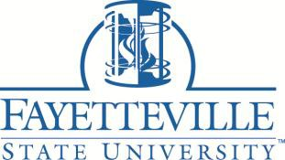

FAYETTEVILLE STATE UNIVERSITY APPLICATION FOR AMERICAN INDIAN/NATIVE AMERICAN SCHOLARSHIP PROGRAM
ADMINISTERED BY THE NORTH CAROLINA STATE EDUCATION
ASSISTANCE AUTHORITY
2021-2022
Application Deadline July 1, 2021

The General Assembly of North Carolina has provided funds for a number of scholarships to residents of North Carolina American Indian/Native American students of the University of North Carolina System. Eligibility for a scholarship under the American Indian/Native American Scholarship program is limited to a person qualifying as follows:

- Admitted or enrolled as a degree seeking student in good standing in an undergraduate degree program at FSU or Doctoral Program
- North Carolina Resident
- Tribal affiliation (attach current documentation of tribal affiliation)

Please note that tribal affiliation is an individual who maintains cultural identification as an American Indian/Native American through membership in an Indian tribe recognized by the State of North Carolina or the Federal Government.

Name Banner ID

Indicate Tribal Affiliation (Please Attach Tribal Card)

I hereby certify that all information I have set forth herein is true to the best of my knowledge, pursuant to my reasonable inquiry where needed.

I hereby acknowledge Fayetteville State University may verify the information set forth herein from sources accessible under law to confirm the affiliation of tribal of American Indian/Native American

Applicant’s Signature Date

