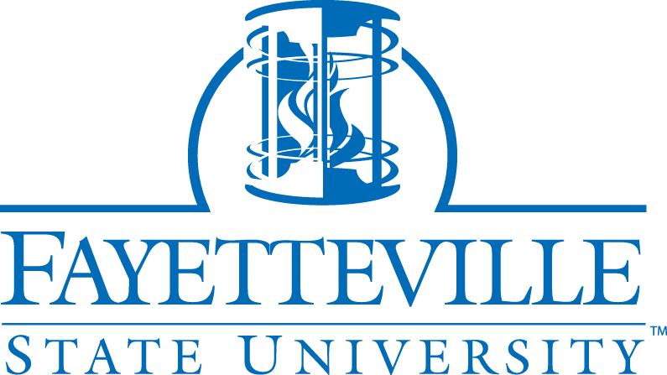
SHOPPING SHEET INFORMATION VETERANS/DEPENDENTS
Section 1018 of Public Law 116-315, Johnny Isakson and David P. Roe, M.D. Veterans Health Care and Benefits Improvement Act of 2020, requires educational institutions to make certain disclosures to students using federal military and/or VA education benefits. To ensure compliance with the law, we have developed the Shopping Sheet Information for Student Veterans and Veteran Dependents.
Estimated cost of courses including tuition, fees, books, supplies, and other additional costs.
The cost of tuition and fees are different if a student is a North Carolina resident or an out-of-state student. For information on the estimated cost, please visit College Navigator - National Center for Education Statistics.
Please note that your final cost depends on you receiving VA benefits to cover tuition and fees, books/supplies, and housing allowance; any aid to cover the cost; taking extra courses such as prerequisites; retaking a failed course; changing your program of study which requires more or fewer credits, change in the cost of living; a change in tuition/fees as approved by State Legislature, etc. Students should visit the FSU website Pay For College | Understand how to Pay for College (uncfsu.edu).
Estimated cost of living expenses.
Students can look up the estimated cost of living expenses by visiting our Financial Aid (FA) website at Cost Calculator at Fayetteville State University (uncfsu.edu)
Amount of cost covered by VA benefits.
Only Chapter 33 recipients may be entitled to a percentage of the following VA Educational Benefits based on your length of Service:
• Cost of tuition and fees for an in-state student (paid to the school and prorated based on the eligibility percentage)
• Monthly housing allowance equal to the basic allowance for housing payable to a military E-5 with dependents, in the same zip code as your school (paid to the student and prorated based on training time and the eligibility percentage)
• Yearly book and supply stipend of up to $1000 per year (paid to the student @ $41.67 per unit and prorated based on the eligibility percentage) VA benefits recipients can visit the following pages for information regarding VA benefits, what are covered by VA and what are not.
Students can search by college to determine estimated GI Bill® benefits, housing allowance, and book stipend using GI Bill® Comparison Tool https://www.va.gov/education/gi-bill-comparison-tool/
Other VA benefits recipients may receive assistance allowances based on training time. Students can view the pay rate on the VA website at Montgomery GI Bill Active Duty (Chapter 30) Rates | Veterans Affairs (va.gov)
Types of Federal financial aid offered by the institution, that the student may be qualified to receive.
Students using veteran education benefits are encouraged to apply for financial aid online.
at www.fafsa.gov to be considered for federal, state, and institutional grants, as well as scholarships. Fayetteville State University School Code is 002928.
Students should also check the College Financing Plan on the Banner Student portal for more information regarding their financial aid package. Be sure to visit the financial aid website Financial Aid | Scholarships | Loans | Grants | Work Study (uncfsu.edu) for available aid offers. Contact the Financial Aid office via email at Contact Financial Aid (uncfsu.edu)

Estimated amount of student loan debt upon completion of a degree or certificate
Students should borrow responsibly. This means only borrowing what you need. Students may borrow (if eligible), between $5,500 to $10,500 per year, depending on their grade level in school and their dependency status. Loan Information at Fayetteville State University (uncfsu.edu)

Use My Federal Student Aid account or the National Student Loan Data System
Log In | Federal Student Aid to find out how much you owe in federal loans.

Graduation Rates for Fayetteville State University
Students can access the graduation rates for Fayetteville State University using College Navigator - National Center for Education Statistics or College Navigator - National Center for Education Statistics
Transfer credits including military credits.
Students receiving VA education benefits are required to submit their all-official college/university transcripts, Military Joint Services transcript (JST), and Community College of the Air Force (CCAF) to receive transfer credits.
Students can visit this page for information about specific program requirements.
Academic Program Finder | Majors and Minors (uncfsu.edu)

Others
Further information on costs, academic requirements, and services available to students can be found on our Consumer Information web page Financial Aid | Scholarships | Loans | Grants | Work Study (uncfsu.edu)
Requirements for in-state tuition
All students must complete Residency Determination Services (RDS)
Students who are eligible for GI Bill® educational benefits include the Montgomery GI Bill®–Active-Duty program. (Chapter 30), the Veterans Readiness and Employment program (formerly called Vocational Rehabilitation and Employment) (Chapter 31), or the post-9/11 GI Bill® program (Chapter 33) are exempt from paying nonresident tuition regardless of when the veteran separated from the military by filling out the Veteran in State form.

Enrollment Certification
Certification for VA Education Benefits each semester is not automatic. Students who wish to receive the benefit must complete the paperwork with the School Certifying Officer (SCO) and must submit the enrollment certification request every semester after signing up for your classes to continue receiving benefits and to prevent delays in payment of benefits.
To request VA certification https://forms.office.com/r/r3ZfyRyyCp or use QR Code

Absence due to Military Service
A student who is an active duty or reservist of the United States military, and who receive orders compelling a withdrawal from courses, should submit a Retroactive Withdrawal Request requesting a Military Drop, with proof of such orders to receive a full refund of those courses (For Chapter 33 students, the school will return the tuition and fees to the VA). An “MD” symbol will be assigned and will not be counted in progress probation, dismissal calculations, or in calculating the permitted number of withdrawals a student is allowed. Students can resubmit the application for admission upon return.
Students who are receiving the VA benefit along with financial aid should be aware that withdrawing from a course(s) will have an impact on their benefit/financial aid status. Students are strongly encouraged to talk to the Financial Aid Department and the School Certifying Official.
VA benefits will stop as of the drop date reported for all classes. Students will be responsible for repaying VA the funds received for such course(s), (BAH/Monthly assistance allowance), or submitting a Mitigating Circumstance to the VA. Need more information email veterans@uncfsu.edu

