Accessing Your Banner Account

- Go to Fayetteville State University home page https://www.uncfsu.edu/
- Select “Faculty and Staff” tab at the top of the page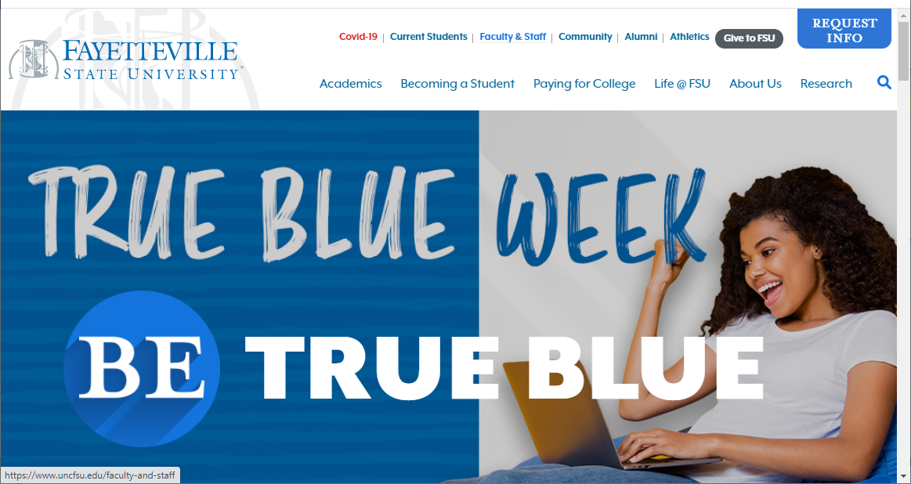
- Select “Banner Login” icon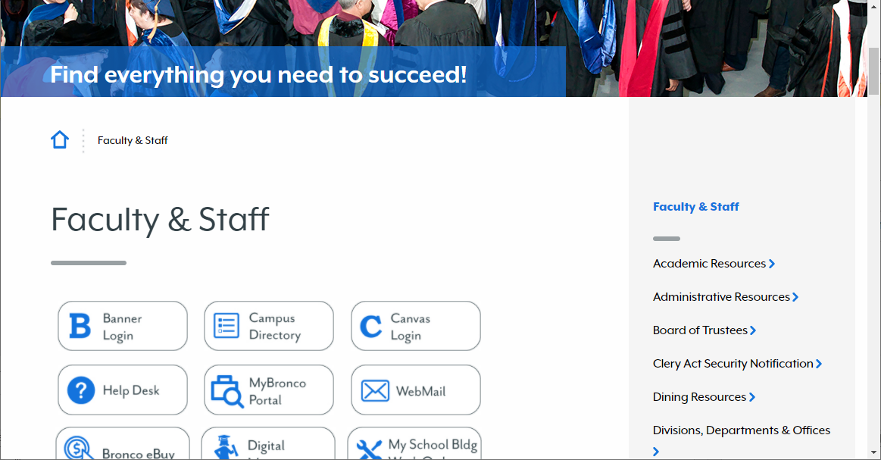
- Enter your employee Banner ID into the “User ID” field and your password into the password field. Click the “SUBMIT” button.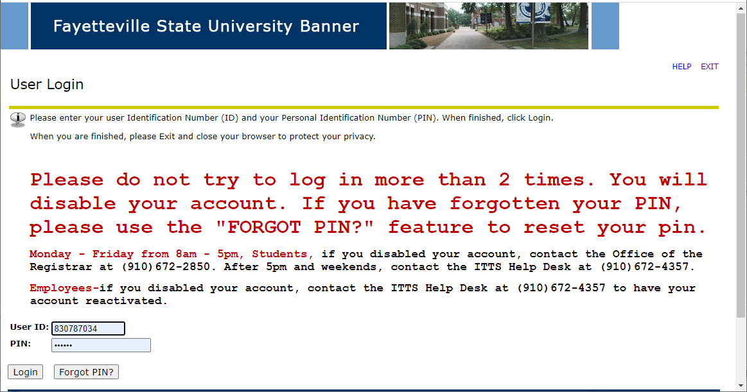
- Select “Employee” link or the “Employee” tab.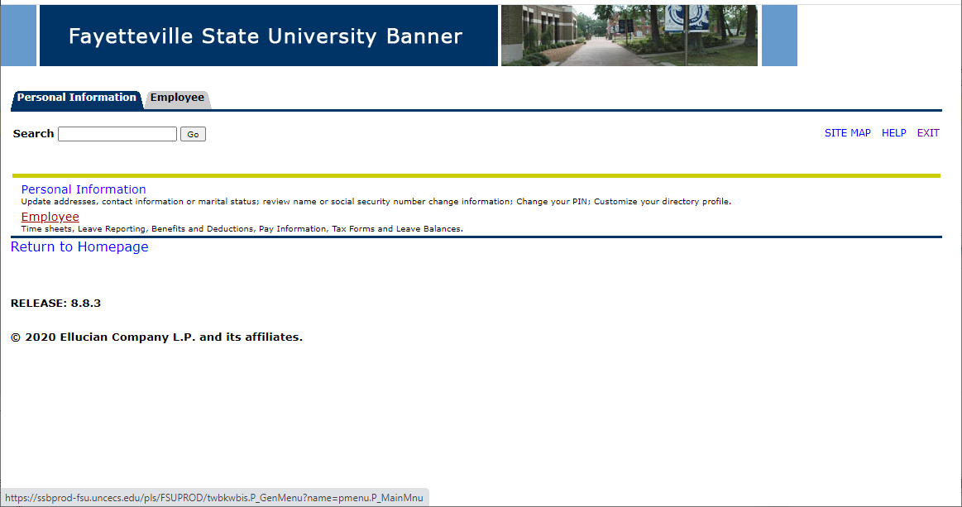
- Select “Time Sheet for Temporary and Student Employees”. 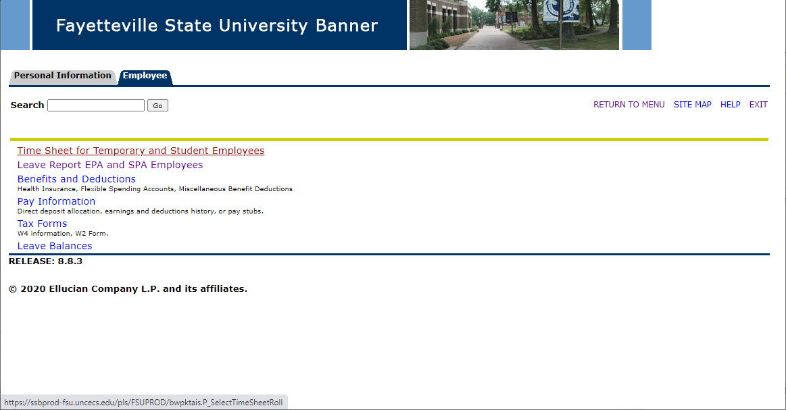
- Select the appropriate job title from the dropdown menu.
- Enter your hours worked. You must use the 08:00 format. Enter “time-in” and “time-out”
- Select “Save”
- Select “Submit”

