How to Install and Use Global Protect VPN Client on Android:

- Open the Play Store and install the Global Protect app by Palo Alto Networks. Tap Open to launch the app.

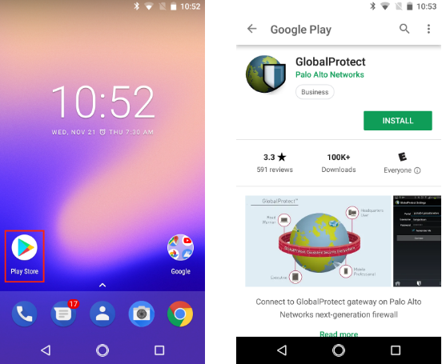

- In the Portal field, type vpn.uncfsu.edu, and then tap Connect.
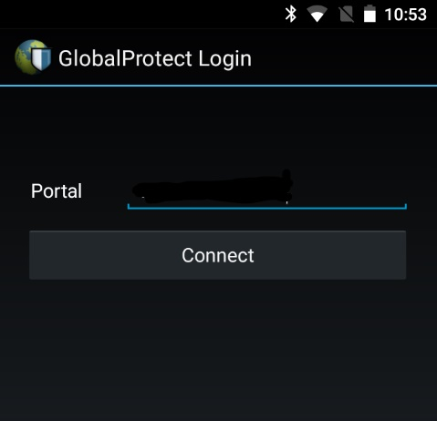

- Enter your NetID and password in the Username and Password fields, and then tap Connect.
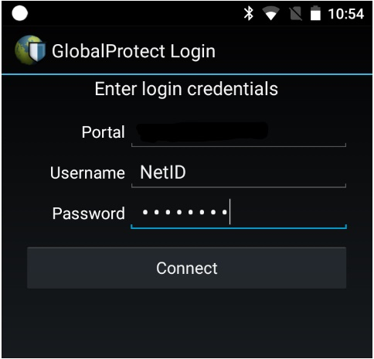

- Tap OK on the Connection request dialog to let Global Protect set up the vpn connection.
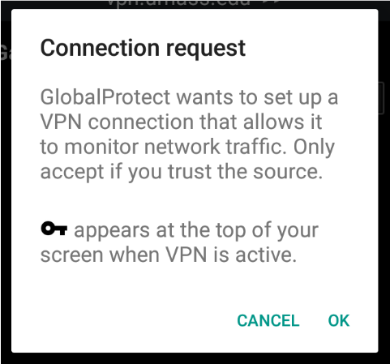

- Global Protect will send a notification when you are connected to the VPN service.
