How to Install and Use GlobalProtect VPN Client on MacOS:

- Browse to https://vpn.uncfsu.edu in your web browser.

- Log in using your FSU username and password.

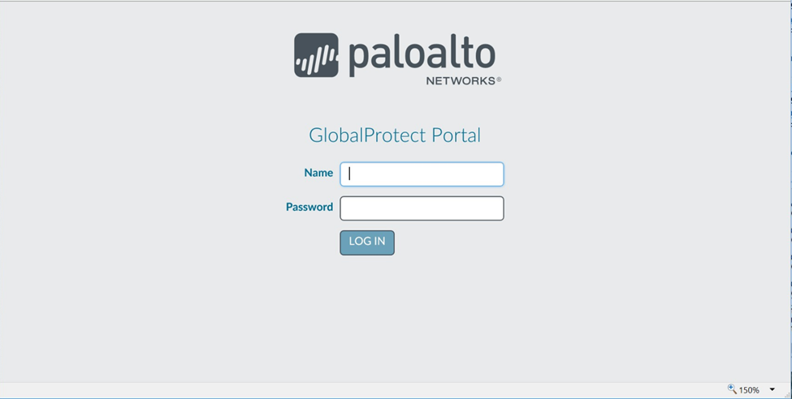

- Click 'Download Mac 32/64 bit GlobalProtect agent' and then 'save file' to download the installer.

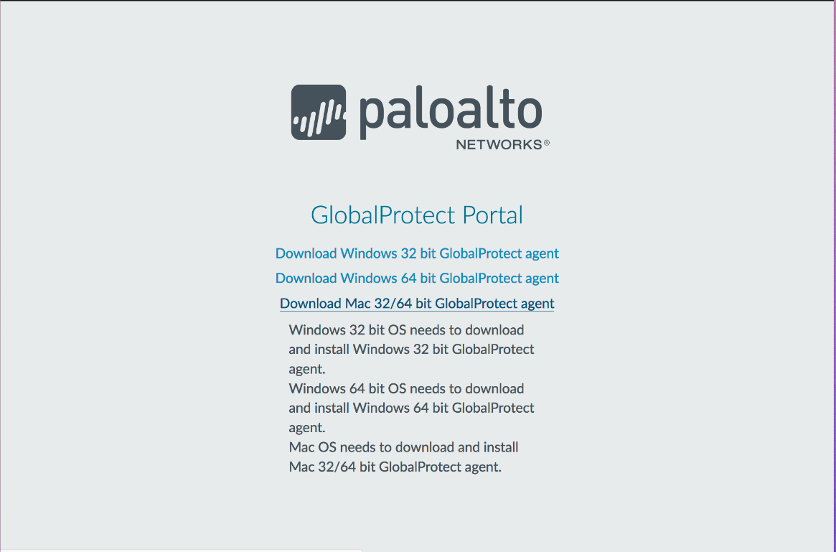

- Run the downloaded file. You will need your computer's admin username and password to install.
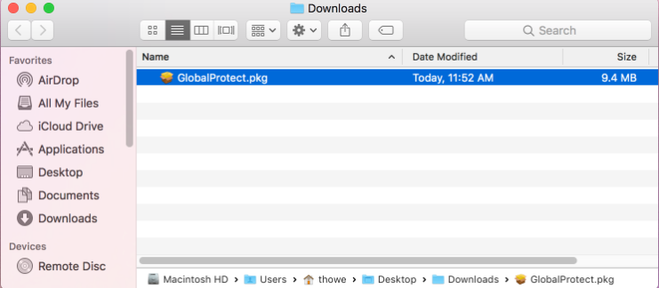
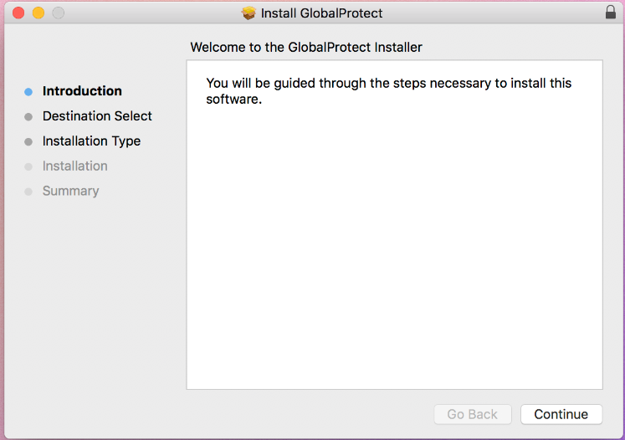
- From the GlobalProtect Installer, click continue.

- On the destination select screen, select the install folder and then click continue.
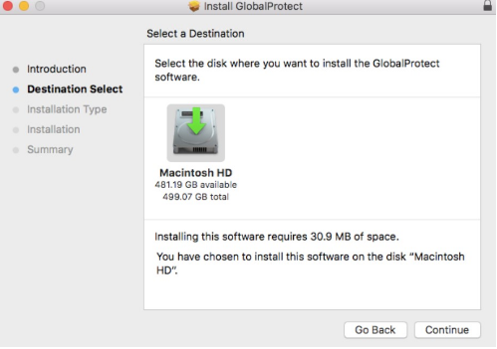
- Click install to confirm that you want to install GlobalProtect.
- When prompted, enter your Username and Password, and then click install software to begin the installation.

- When this security box appears, users MUST click the “Open Security Preferences” Button (NOT the OK Button)
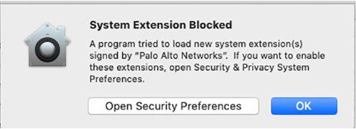

- Click the “Allow” button at the bottom of the “Security & Privacy” box to allow the Palo Alto Extension.
- After installation is complete, close the installer.
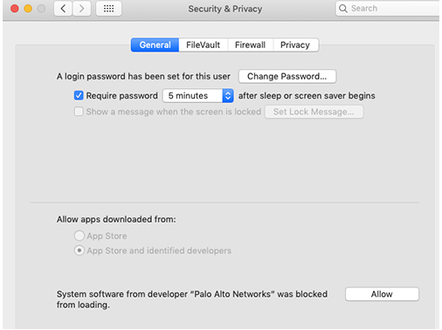

12.Type vpn.uncfsu.edu into the Portal Address field and click Connect. Choose from the dropdown box (Staff, Banner, or Vendor) then sign in with your username and password.
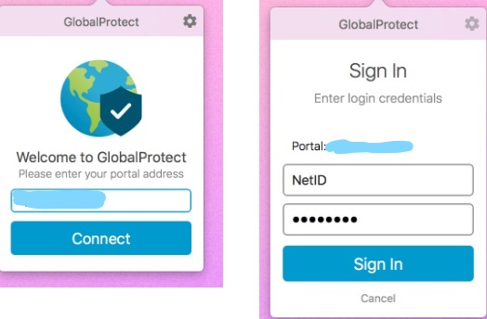
13.Once you are connected to the VPN, the global protect icon in the menu bar will show a white shield.
