How Install and Use GlobalProtect VPN Client on Windows:

- Browse to https://vpn.uncfsu.edu in your web browser.

- Log in using your FSU username and password.

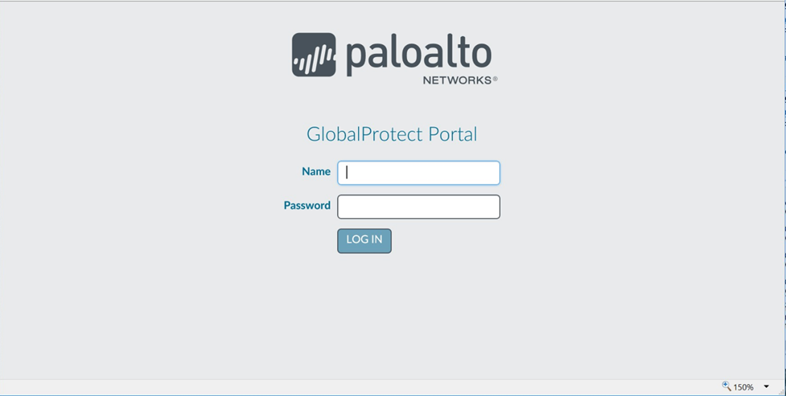

- Click either 'Download Windows 32 bit GlobalProtect agent' or 'Download Windows 64 bit GlobalProtect agent.' Click Run to run the file as soon as it is done downloading.

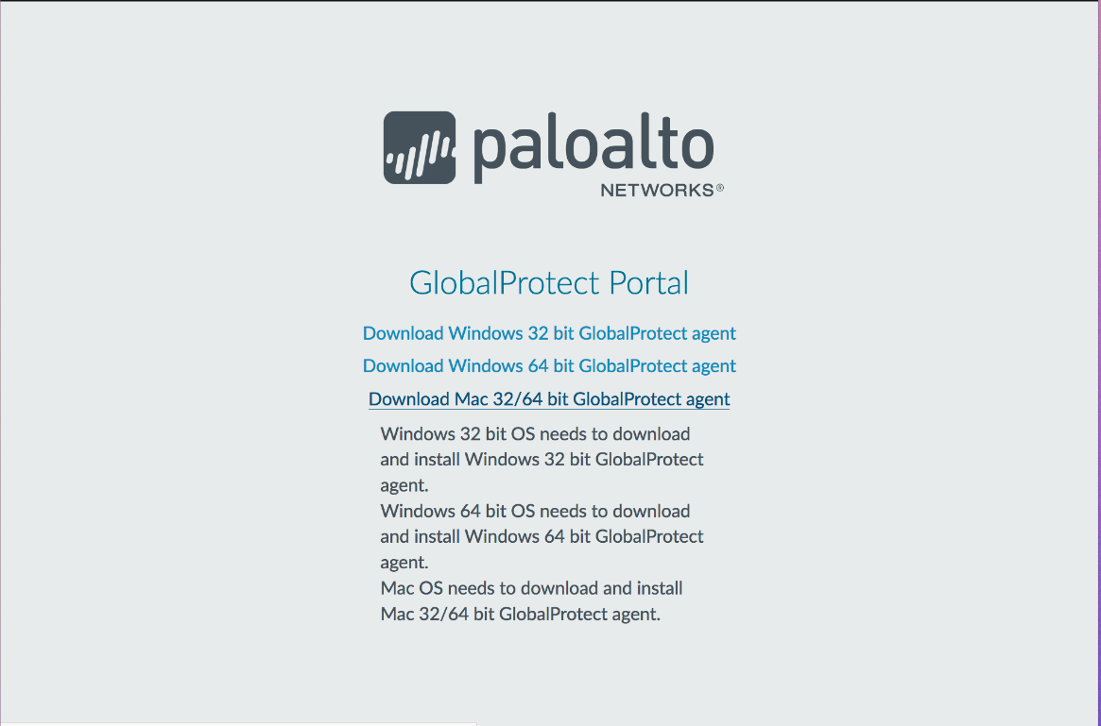

- If you are not sure if you have 32 or 64 bit Windows, you can check by opening the Settings app and navigating to System/About.
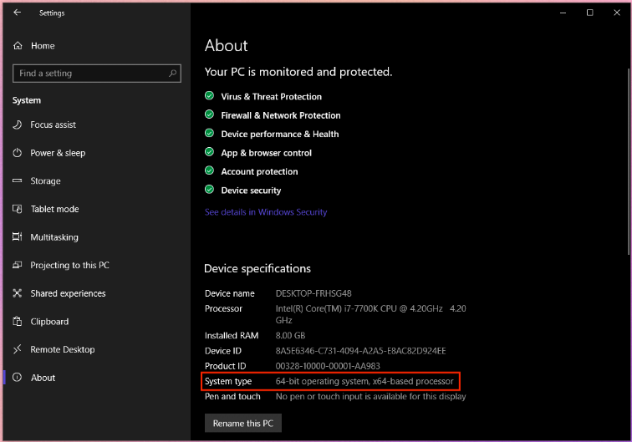

- When the file has downloaded, the Global Protect installer will run. Click Yes on the User Account Control dialog. You may be prompted for your computer's admin username and password.
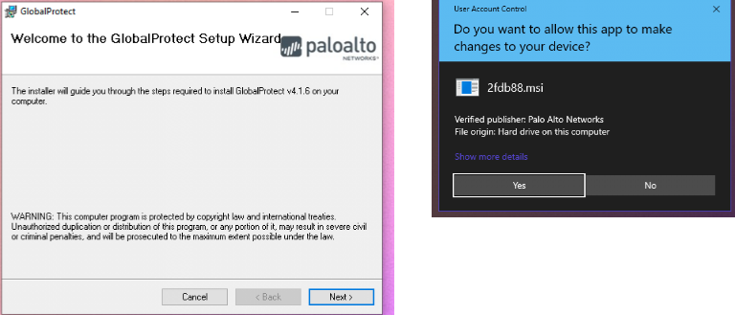
- Once the client has been installed, the Global Protect icon will appear in the notification area in the taskbar at the bottom right of your screen. Click the icon to set up the VPN connection.

- Type vpn.uncfsu.edu into the Portal Address field and click Connect. You will be prompted to sign in with your username and password.
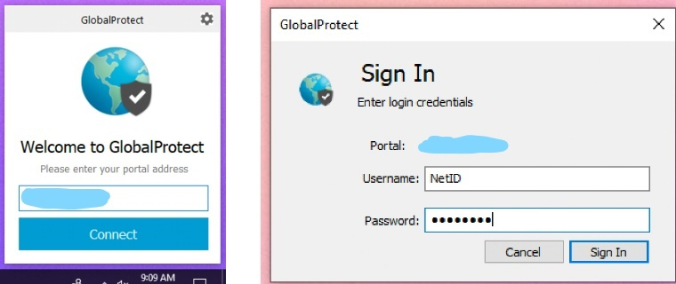
- Once you are connected to the VPN, the global protect icon in the menu bar will show a gray shield.
