How to Install and Use Global Protect VPN Client on iOS:

- Open the App Store and install the Global Protect app by Palo Alto Networks. Once it is installed, launch the app.

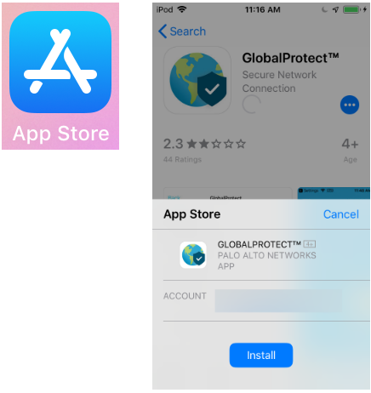

- Type vpn.uncfsu.edu in the portal Address field and tap Connect.

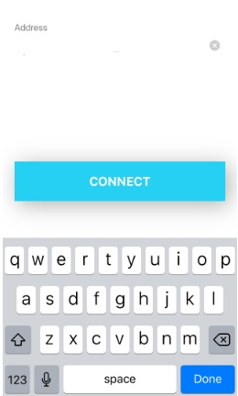

- Tap Allow on the dialog asking to give Global Protect permission to add VPN configurations. You will be prompted for your iOS device's pin (or other authentication method).

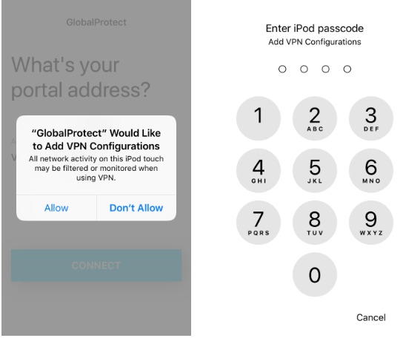

- Enter your NetID and password in the username and password fields, and then tap Connect.

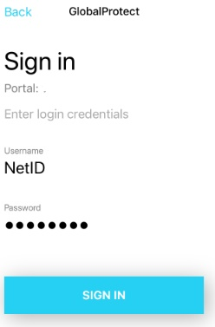

- The VPN icon will be displayed in your iOS device's status bar when you are connected to the VPN service.

