The Department of Mathematics and Computer Science has reached an agreement with Microsoft's Azure Dev Tools for Teaching Program (previously named MSDNAA, Microsoft DreamSpark and Microsoft Imagine), which allows all faculty, staff in our university who has an email address in the uncfsu.edu and broncos.uncfsu.edu domain to download selected Microsoft software to be installed on their own computer. Microsoft has recently streamlined the process. Students no longer have to fill in an application form to enjoy this benefit.
- Download Site (https://azureforeducation.microsoft.com/devtools)
- Once the site is loaded, click the sign in button. You will then be asked to sign in with your broncos email address and your email password.
- You will be redirected to the Azure Dev Tools for Teaching page.
- Click “Software” as highlighted in the following figure:
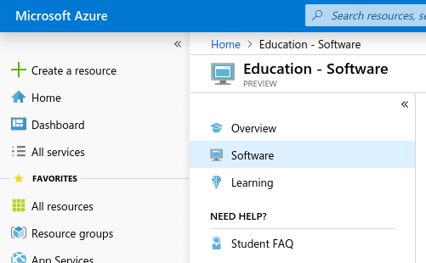
- The page will then be updated with a list of all software you can download. You can also use the search feature to narrow down the items you are looking for.
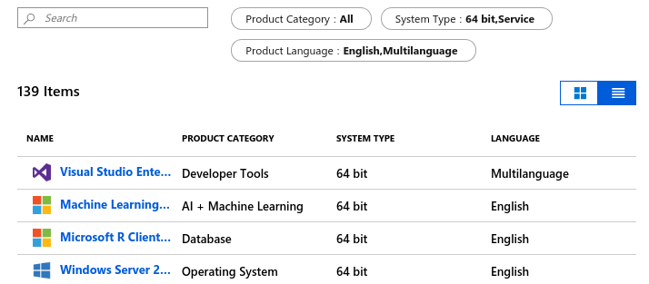
- Once you have found the software you would like to download, click on it and a sub-window will show buttons for retrieving the key (if appropriate), and for downloading the software:
